Master Functional Document

Application | NGERP - Centra
Service Bundle | Master Management
Service Request | Sales Channel

Description :

Region is seperated by sales using Sales Channel master. This master is mapped to program Threshold Mapping master to group the regions into sales region.

Workflow Process :

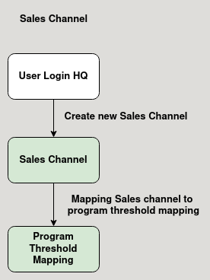

Business Rules :

- User should login into HQ to create a Sales Channel.
- This channel is used to categorise regions by sales region.
- After creating the sales channel it is mapped to the program threshold mapping master.

